City of Forks

REQUESTS FOR QUALIFICATIONS

FOR

PROFESSIONAL
ENGINEERING SERVICES

AT THE

QUILLAYUTE AIRPORT

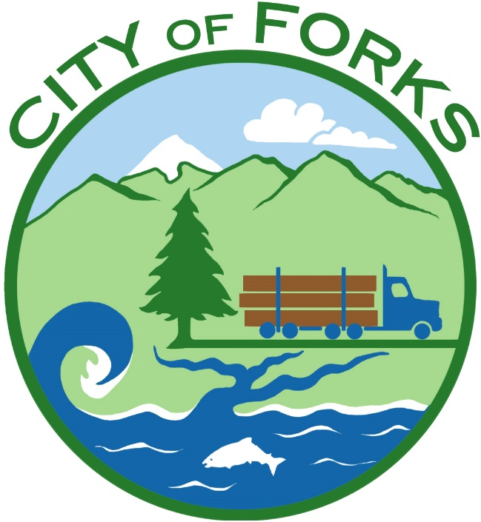

REQUESTS FOR QUALIFICATIONS
For
AS-NEEDED PROFESSIONAL ENGINEERING SERVICES
For the
Quillayute Airport (UIL), City of Forks, Washington

- INTRODUCTION

RFQ information is available at www.forkswashington.org Or email rodf.forks@forkswashington.org

The City of Forks as sponsor of the Quillayute Airport, a public use airport facility, invites interested qualified persons and firms to submit Statements of Qualifications (SOQ) for engineering design and construction management/inspection services of various as-needed airport improvement projects at the Quillayute Airport. Projects may require planning and environmental work necessitated by federal requirements for a particular project – (e.g. project coordination and planning level project layout, airspace, or categorical exclusion documentation). Persons and firms should have the knowledge, expertise, experience, and professional credentials to accomplish project engineering design and construction management/inspection services for airport development that complies with Federal Aviation Administration (FAA) Airport Improvement Program (AIP) requirements, FAA Advisory Circulars (AC’s), and federal, state and local laws, regulations and standards.

The City of Forks selection process is intended to be in compliance with the FAA AC 150/5100-14 (latest edition) entitled “Architectural, Engineering and Planning Consultant Services for Airport Grant Projects”.

The runway rehabilitation project and other airport improvement projects listed in this Request for Qualifications (RFQ) are anticipated to be funded in part by the FAA with AIP grant funds, WSDOT-Aviation funds, and/or the City of Forks funds.

In 2017, the City is planning to undertake a runway rehabilitation project to Runway 4/22 Rehabilitation Project, in general, this project includes maintenance and repair concrete panel joints, and repair/replace damaged concrete panels; identification of obstructions in the Runway 4/22 approach by ground survey; and, if needed grade the runway safety area, and remove obstructions (e.g. trees) located on airport property. The City of Forks has submitted a preliminary grant application with FAA and anticipates a total project budget of less than $200,000 (includes City of Forks matching AIP grant funds).

It is the City of Forks desire to have selected a consultant and negotiated a contract so that design may commence by 15 Feb 2017, environmental project documentation is submitted to the FAA by3 1 Mar 2017; and open bids for construction by 15 Jun 2017. By June 1, 2017, the City of Forks plans to submit an AIP grant application to the FAA for both design and construction for rehabilitation of Runway 4/22.

- SOQ FORMAT and TIME SCHEDULE

- Please limit your SOQ submittal package to 20-pages total and provide four (4) copies. Submittal packages will not be returned.

Address submittal package to:

City of Forks
Quillayute Airport Engineering Services SOQ
Forks, WA 98331
Attention: Rod Fleck

Any Qualification documents received after the below date and time will be returned unopened.

Submittals must contain the name, address, and daytime telephone number for contact person(s) to whom additional selection process requests should be communicated. All submittals must be clearly labeled in all capital letters “STATEMENT OF QUALITICATIONS FOR QUILLAYUTE AIRPORT” on the back of the envelope. Unlabeled submittals may be returned to the sender without further consideration.

- The City of Forks will endeavor to use the following time schedule in its selection:

- Statement of Qualifications must be received by 2:00 p.m., 30 Jan 2017 at 500 East Division Street, Forks, Washington, 98331.

- Preliminary evaluations of qualifications will be made approximately 10 Feb 2017 with a recommendation to the Forks City Council on 13 Feb 2017.

- If the Selection Committee determines interviews are required, the City of Forks will coordinate a time to meet. Interviews would most likely occur on the 8th or 9th of February.

- Interested persons and firms will be notified of either selection, or short listing for in person or phone interviews approximately 3 Feb 2017.

- PROJECT LIST

Professional services for engineering design and construction management/inspection services are needed to implement AIP development projects. Work may include the following projects:
- Rehabilitate Runway 4/22
- Runway 4/22 safety area improvement
- Remove obstructions
- Replace/install visual nav-aids (e.g. beacon, segmented circle)
- Fencing
- Other miscellaneous airport projects that benefit airport users or may be eligible for funding under the AIP.

- NO PRICE OR PRICING INFORMATION

SOQs submitted by any interested persons or firms shall NOT include prices or any pricing information for proposed engineering design or construction management-inspection services. FAA AIP grant guidelines require cost and fee information to be presented during contract negotiations after selection of the most qualified consultant with which to negotiate.

- COST OF RESPONDING TO THE RFQ OR CONTRACT NEGOTIATIONS

Interested applicants should not expect compensation of costs associated with the SOQ submittal package, interview, or subsequent contract negotiations – if selected. Any and all costs associated with responding to this RFQ or negotiations shall be born solely by the applicant.

- RIGHT TO REJECT FOR ANY REASON

After the City of Forks selects a consultant for engineering design and construction management/inspection, the City of Forks does not guarantee implementation of design or construction of some, all, or none of the airport projects listed in this (RFQ).

City of Forks reserves the right to reject any or all SOQ, proposals or submittals; cancel the RFQ; cancel all, some or specific project listed in this RFQ; and reserves the right to withhold the award to any contract relating to the RFQ, or negotiated unsigned contract for any reason City of Forks determines.

- LEGAL REQUIRMENTS

Persons or firms submitting a SOQ and their sub-consultants must be duly licensed to perform architectural/ engineering design services – (or licensed for other similar professional services) for the work at the time the SOQ is submitted pursuant to all applicable federal, state, and local laws, rules and regulations. If a licensing exemption is claimed, the person or firm should set forth the basis of the claimed exemption in writing at the time of the SOQ is submitted.

- CONTRACT LIMITATIONS

- Contracts and subcontracts will be subject to the provisions of Executive Order 11246 (affirmative Action to Ensure Equal Employment Opportunity) and to the provisions of Department of Transportation Regulations 49 CFR Part 26 (Disadvantaged Business Enterprise Participation) and 49 CFR Part 30 (Foreign Trade Restriction Clause).

- Contracts and subcontracts will be subject to “Required Contract Provisions for Airport Improvement Program (AIP) and Obligated Sponsors”. The full text is located at https://www.faa.gov/airports/aip/procurement/federal_contract_provisions/.

- The sponsor reserves the right to initiate additional procurement action for any of the projects or services include in this RFQ.

- The work advertised may be accomplished over the course of multiple AIP grants. The services are limited to those projects in this RFQ, and may be limited to those projects initiated within five (5) years of the effective date of the executed contract for the initial airport development project. A project started within the first
5-years may continue beyond the duration of the initial contract; however once the 5-year duration has ended no new project will be initiated without a new procurement action.

- If the conditions listed in Advisory Circular 150/5100-14 (latest edition) exist, additional projects or work elements may be added after the original selection with mutual agreement between the City of Forks and the FAA.

- The City of Forks will rank qualified persons and firms in order of preference, and initiate negotiations with the highest ranking consultant. In the event that the City of Forks and the selected consultant negotiate but are unable to agree upon a detailed scope of work or cost of contract, the City of Forks reserves the right to negotiate with and/or award a contract to other person or firm sequentially ranked next (by the sponsor’s selection committee) behind the selected consultant.

- ENGINEERING SERVICES – EXPERIENCE AND QUALIFICATION CRITERERIA

- Qualifications will only be accepted from firms that can demonstrate having had a broad background and extensive experience in the field of airports and the AIP requirements for grant management and engineering design, bidding services, and construction management/inspection.

- Submittals will be evaluated by the below-listed criteria. They should be organized and identified in the same order.

- General description of firm: Include company organizational structure, company history and background, size of company

- Describe recent experience in comparable airport projects in a similar environment, and your experience with the FAA, Airport Improvement Program, federal AIP grant aid, and Washington State Department of Transportation – Aviation grant program.

- Knowledge, experience, qualifications and capability of your firm successfully complying, performing, and administering all requirements of the FAA AIP grant program, AIP airport design and construction standards, airspace requirements, as well as familiarization with FAA Orders and Advisory Circulars, and NEPA process.

- Affiliation with other firm(s): Identify qualifications and experience of other firms that you plan to subcontract or joint venture with, if any, for the proposed fiscal year 2017 project, and possible other projects listed in this RFQ. Please identify the portions of the project anticipated to be performed (in part) by subconsultants.

- Identify key person(s) in firm(s) who will work on the design and field engineering portion of the projects, and who will be directly in charge of the City of Forks’ projects. Describe the roles these key persons will fill, their background and their experience. Please include a description of where key personnel for AIP projects will be based, and other items you consider important to demonstrate this ability to furnish qualified engineering design and engineering-construction management/inspection services.

- Current workload of firm and key personnel: List the anticipated percentage of time the project manager will have available for airport projects for the City of Forks.

What is the availability of key personnel to proceed with the design and construction phases for Runway Rehabilitation project and open bids by June, 2017, at the City of Forks’ airport. This section should include a depiction of the firms proposed project schedule, including major tasks and target completion dates. Please do not include costs or fees, as this information will disqualify your SOQ.

- Technical approach: A brief discussion of the tasks or steps that the consultant will undertake to accomplish AIP eligible work.

- Describe quality of projects previously undertaken. Please provide a list of all current airport development projects, as well references from all airport development projects that have been completed within the last three (3) years; include contact person, airport, project(s), and phone number(s). Please highlight those references from comparable airports. The City of Forks reserves the right to contact former clients identified by the consultant in their SOQ to ascertain the quality of work, ability to meet schedules, costs control and consultant client relationships.

- Demonstrated capability to meet schedules, deadlines, without delays, cost escalations or overruns and contractor claims.

- Evidence that the consultant has established and implemented an Affirmative Action Program (see “DBE participation” in Selection section, below).

- Description of ability to qualify as a Disadvantaged Business Enterprise (DBE) under 49 CFR 26 – (if unable to qualify, so state).

- Detailed description of ability to purchase supplies and/or services from qualified DBE - (if unable to purchase, so state)

- SELECTION: EVALUATION CRITEIRIA AND WEIGHING

The selection of the person or firm to do the work will be done by a committee selected by Bryon Monohon, Mayor. After the deadline for receipt of qualifications, the subcommittee will review the experience and qualification data obtained from consultants, and may select one firm to negotiate a contract based upon a subsequent mutually understood, detailed scope of work. If deemed necessary by the committee, at least two (but not more than 4) firms may be invited for interviews. Interviews may be located at 500 East Division Street, Forks Washington, by phone, or by vid conference. The final selection of the firm with which to negotiate a contract will be based upon persons or firms experience and qualifications data listed above.

The selection criteria that will be used by the committee to rank statements of qualifications are listed below.

Capability to perform all or most aspects of listed projects. Experience and qualifications of persons or firms in complying with the overall requirements of the FAA AIP grant program, as well as familiarization of FAA Advisory Circulars, FAA AIP Standards and regulations, FAA AIP and Washington State DBE requirements.
(15 points)

Recent successful experience in airport projects comparable to listed proposed projects. Demonstrated understanding of project potential problems at Quillayute Airport and the airport owner’s special concerns.
(15 points)

DBE participation may be noted but is not part of the consultant selection rating system.

The City of Forks will establish a DBE plan, if required by FAA regulations. The RFQ submittal should include the following information:

- Description of the kind of work that can be subcontracted.

- The estimated percentage of the kind of work subcontract work.

- Identification of subcontract work items which could be performed by DBE firms.

- Name, address, and name of certifying agency of those DBE firms that are anticipated to perform the work items identified in item number three.
(Scoring: N/A)

Key personnel’s professional background and successful relevant experience. Reputation for personal and professional integrity and competence.
(15 points)

Quality of projects previously undertaken.

Familiarity with products required by the Airport Improvement Program and products that need FAA approval.

Demonstrated ability to meet design and construction standards for AIP projects, and meet project schedules and deadlines. Demonstrated ability to complete AIP projects without having major cost escalations, overruns, or disputed claims during design or construction.
(15 points)

- Demonstrated ability to properly manage and complete projects that may be a considerable distance from persons or firms submitting a SOQ.
(10 points)

- Capability to furnish qualified and experienced construction project engineer and qualified inspector.
(10 points)

- Construction contract manager and inspection services: experience, knowledge and expertise with AIP projects. Construction contract manger and inspector skills and ability to implement and enforce AIP construction contracts, and ensure construction meets AIP construction acceptance requirements; ability to complete projects on budget and on time; and demonstrated capability to properly administer projects funded by the Federal Aviation Administration Airport Improvement Program (AIP) and Washington State Department of Transportation – Aviation Grant Program, (references and examples).
(10 points)

- Degree of interest and responsiveness shown in the City of Forks’ project list and challenges.
(10 points)

SELECTION COMMITTEE:

The City of Forks reserves the right to accept any proposal that is deemed to be in the best interest of the City of Forks and the Quillayute Airport.

It is understood that all submittals shall become the property and a part of the public file of the the City of Forks, without obligation to the City of Forks, and may thereafter be used by the City of Forks, without compensation to the Proposers.

The contents of any Statement of Qualifications shall not be disclosed so as to be available to competing offers during negotiations process.

ADDITIONAL INFORMATION

No cost or fee schedules for engineering design and construction management/inspection services shall be submitted. FAA grant guidelines require cost and fee information to be presented during contract negotiations for a specific Airport Improvement Program project workscope after the selection of the most qualified consultant with which to negotiate.

Incurring Costs

The consulting firm is responsible for all costs related to the submittal of their applications, preparation of documents or submittals needed for negotiations, and the costs incurred in traveling to and participating in any meetings associated with the City of Forks’ consultant selection process and/or negotiating an agreement.

